Instructions to be followed while submitting forms online

- With effect from 01st Feb 2010, all the candidates have to register through IRDA Portal.
- A Unique Reference Number would be generated for each candidate at the time of registration.
- Preferred Examination Date is mandatory.
- Ensure that the status of the URN is “Confirmed For Exams”, before sending the DDs to NSE.IT Limited
- Care to be taken while uploading Photo and Signature :-
- The photo and signature uploaded on the portal should be clear.
- 80% of the photograph should cover the candidate’s face.
- Photograph should be a recent one and the size should be between 5 KB and 50 KB
- Candidate’s signature should be clear and the size should be between 5 KB and 10 KB.
- Insurance company should ensure that the contact details updated on IRDA Portal for communicating the exam related information is correct.
- Insurance Company should select the appropriate Payment mode on IRDA Portal.
- Insurance Companies maintaining credit balance with NSE.IT Ltd should select CR option in payment field.
- Insurance Companies sending Demand Draft at NSEIT should select DD option in payment field. The exams would be scheduled only after receipt (and clearance by bank) of Valid Demand Draft (Please refer below mentioned “Check Points for Valid DD”).
- Demand Draft has to be sent to the following address:
NSE.IT Ltd
Online Exams Dept.
Ground floor, Andheri-Kurla Road,
Opposite Lotus Suites, Behind Trade Star Bldg,
Andheri (East), Mumbai – 400059
Tel: 022- 42706500
Email: iiiexam_reg@nseit.co.in
- Demand Draft should be in favor of “NSE.IT Ltd” and payable at Mumbai.
- Only Demand Drafts drawn from Nationalized Banks are accepted.
- For every batch of candidates scheduled, a single DD will be accepted. (Quote the Batch number generated while requesting the online exam schedule on IRDA portal)
- A covering letter is also to be sent with the Demand Draft with the following information :
    - Name of the Coordinator
    - Mobile Number
    - Landline Number
    - Email ID of the coordinator
    - List of candidates with name, URN and Batch number (as generated on IRDA portal while registering the candidates).

- The exam scheduling will be done either on preferred exam date provided or any subsequent date based on availability.
- Any other mode of requests for reservation of seats will not be entertained.
Contact details for the NSE.IT’s H.O
Telephone number – 022-42706500.
E-mail address – iiiexam_reg@nseit.co.in
Address – NSE.IT Ltd (Online Exam Center), Ground floor, Andheri-Kurla Road, Opposite Lotus Suites, Behind Trade Star Building, Andheri (East), Mumbai – 400059
Working Days - Monday – Friday 9.30am to 05.30pm

- The confirmation of Exam Date and Time would be mailed to the Insurance Companies and Hall Tickets would be updated on IRDA portal by evening.
- Training Completion Certificate status should be updated by ATIs on the Portal by 06.00 PM on previous working day (i.e. Sundays and Public Holidays will not be considered as working days) before the scheduled exam date of the candidate.

Check Points of Valid DD

Favouring name
Bank Name Nationalized bank
DD Issue date

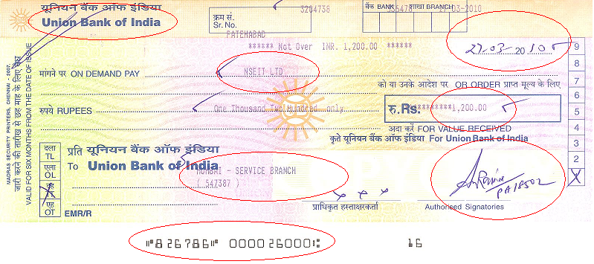
DD amount
MICR NO
Signature
Payable at Mumbai
DD NO

The Demand Draft has to be checked for the following:

- The DD should be drawn in favour of “NSE.IT Ltd”.
- Check the Issuing date and Validity period of the DD: Some are valid for six months while others are valid for three months only. The date must be clearly visible.
Note: On the date of receipt by NSEIT, the DD must be valid for at least another 20 days. Example: The issuing date of the DD is 4 May 2011. The validity period is stated as six months. So the expiry date would be 4 November 2011. NSEIT receives it on 2 November 2011, which is technically within the validity period. However, for all practical reasons, it may not reach the bank before expiry. So the DD shall be treated as invalid.
The draft would be treated as valid if only it is received by 15 October 2011.

- DD amount should not be excess. It should match with the URN contained in 1 batch.

- DD’s issued by nationalized will only be accepted.

- DD must be payable at Mumbai. In case ‘Mumbai’ is not mentioned, the number indicating “payable at par” should be mentioned.

- Stamp and signature of the bank official must be clearly visible.

- Amount in numbers and words should match

- In case of any correction or overwriting, it must be signed by the same signatory.

In case the DD bears the statement “Valid only if computer printed,” and the entries are made manually, then it will be treated as invalid

